LAB Logbook

Lab 1

Lab 2

Test Accuracy: 0.922

Lab 3

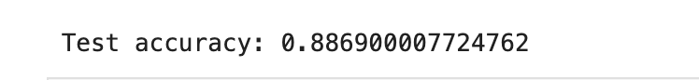

Lab 4

Lab 5

Lab 6

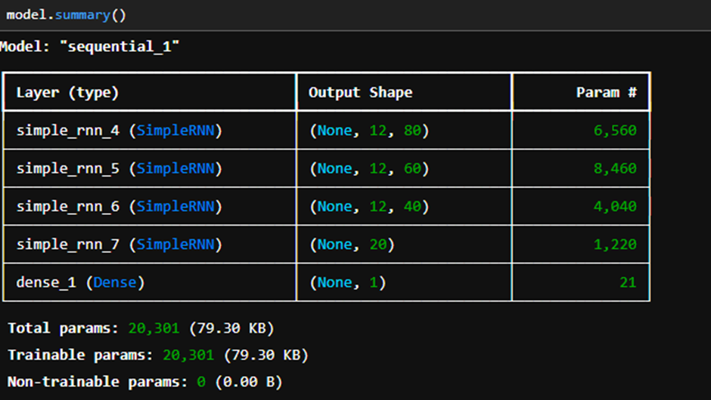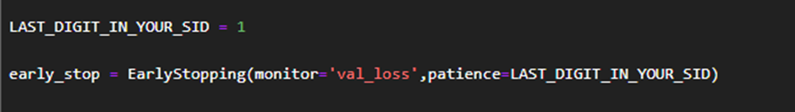

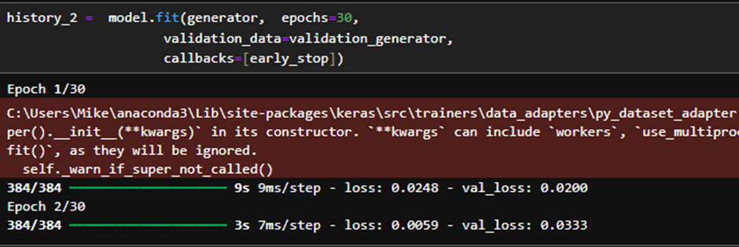

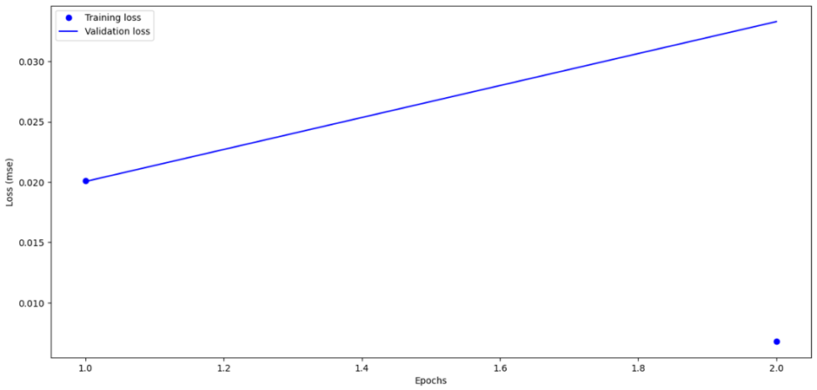

Lab 7

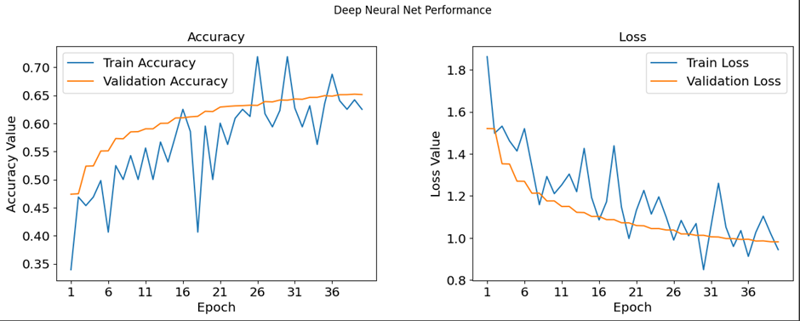

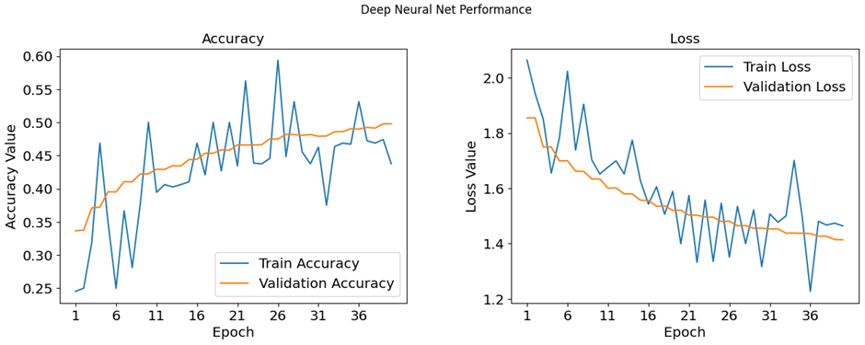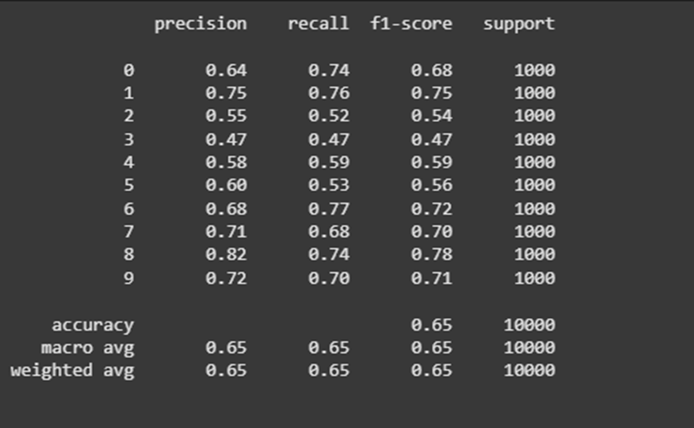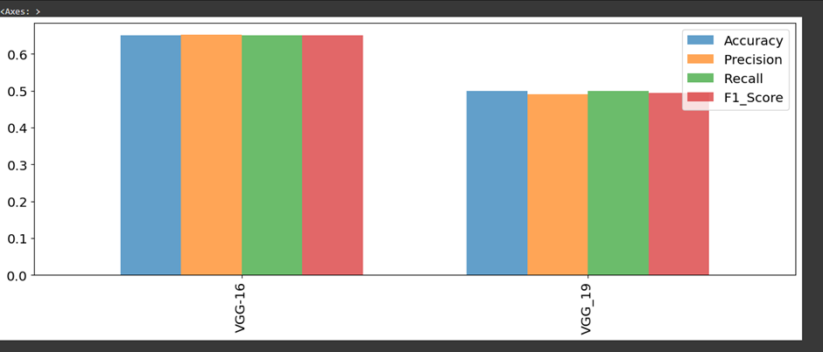

**Number of epochs=30**

Lab 8

Lab 9

Lab 10

Lab 11

Lab 12